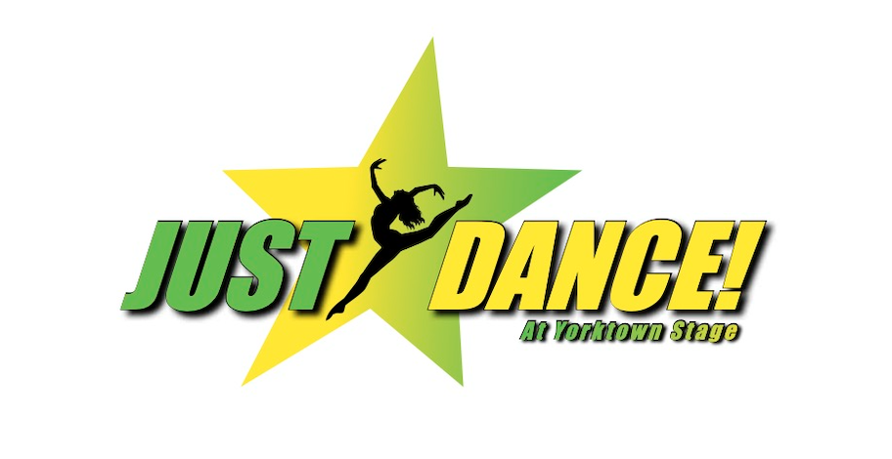

**DRESS CODES**

**2024-25**

*(Classes are listed alphabetically)*

Acting Classes

■ Boys and Girls:

○ T-shirts and pants or shorts

○ Hair supplies to keep hair fully off face

○ Sneakers or other shoes that fasten

○ Slippers and crocs are not allowed

○ No skirts

Advanced Ballet Students

■ Girls:

○ Any solid color leotard

○ Light pink tights

○ Light pink ballet slippers

○ (With no strings is preferable)

○ Ballet skirts when in pointe shoes

■ Boys:

○ Solid color t-shirt

○ Gym shorts or bike shorts

○ White socks

○ White ballet slippers

Ballet Tap Jazz Class

■ Boys and Girls:

○ Tights and a bodysuit (girls)

○ Black Dance pants and a tee shirt (boys)

○ Black theatrical child buckle tap shoes

○ Ballet Shoe will be used for ballet and jazz (for jazz routine they will wear ballet shoes)

Beginner Ballet Students

■ Girls:

○ Any solid color leotard

○ Light pink tights

○ Light pink ballet slippers

○ (With no strings is preferable)

○ Hair in a ponytail or bun

■ Boys:

○ Solid color t-shirt

○ Gym shorts or bike shorts

○ White socks

○ White ballet slippers

Bippity Bop Students

■ Girls:

○ Any solid color leotard

○ No skirt or decorations

○ May be long or short sleeve

○ Light pink or white tights

○ Light pink or white ballet slippers

○ (With no strings is preferable)

○ Hair in ponytail or bun

■ Boys:

○ Solid color t-shirt

○ Gym shorts or bike shorts

○ White socks

○ White ballet slippers

Broadway Dance Classes

■ Girls:

○ Any style solid color leotard

○ Black tights, jazz pants or shorts (spandex)

○ Black jazz shoes (students may not dance in socks)

○ Heeled character shoes will be discussed in class

■ Boys:

○ Solid color snug fitting t-shirt

○ Black bike shorts or jazz pants (spandex)

○ Black jazz shoes (students may not dance in socks)

■ Girls and Boys:

○ No sweats or street clothes

○ Hair supplies to keep hair fully off face/neck

Hip-Hop Lyrical Classes

■ Boys and Girls:

○ Booty Shorts or leggings (girls)

○ Dance Pants or tighter fitting sweat pants (boys)

○ Tank top or tee shirt, tighter fit

○ Caramel Tights for the Girls

○ Hip Hop Sneakers

○ Beige jazz shoe for lyrical

Intermediate Ballet Students

■ Girls:

○ Any solid color leotard

○ Light pink tights

○ Light pink ballet slippers

○ (With no strings is preferable)

○ Ballet skirts when in pointe shoes

■ Boys:

○ Solid color t-shirt

○ Gym shorts or bike shorts

○ White socks

○ White ballet slippers

Junior & Senior Company

■ Boys and Girls:

○ Booty shorts or leggings (girls)

○ Dance Pants (boys)

○ Tight fitting, tank top or tee shirt

○ Beige jazz shoe

Modern/Contemporary

■ Girls:

○ Shorts or tight pants

○ Tee shirt

○ Beige jazz shoes

■ Boys:

○ Shorts

○ Tee shirt

○ Black jazz shoes

■ Girls and Boys:

○ Barefoot for the modern portion

Saturday Jazz Classes

■ Girls:

○ Any solid color leotard

○ Light pink or black tights

○ Bloch tan slip-on jazz shoes

○ Solid color booty shorts or …

○ Jazz pants if desired

■ Boys:

○ Solid color t-shirt

○ Gym shorts or bike shorts

○ White socks

○ Bloch tan slip-on jazz shoes

Tap Jazz Classes

■ Boys and Girls:

○ Booty shorts or leggings (girls)

○ Dance Pants (boys)

○ Fitted tank top or tee shirt

○ Black tie up tap shoes (split sole)

Technique Production Classes

■ Boys and Girls:

○ Booty Shorts or leggings (girls)

○ Dance Pants (boys)

○ Caramel Tights

○ Tank top or tee shirt, tighter fit

○ Beige slip on jazz shoe

Ballet Shoes

 Ballet shoes are available at a lot of price points. The cheaper ones are less flexible and don't last as long. The shoes should fit VERY snugly with little or no room at the toe and when you gather up the string, there should be no gapping remaining anywhere. They stretch as you wear them, most students try them on and immediately think they don't fit! Follow the size guides on whichever website you choose, usually ballet shoes are 1-3 sizes smaller than street shoes. Websites to order from: discountdance.com, amazon.com, etc. Brands from best quality downward: Bloch, Capezio, SoDanca, Theatricals. Ms. Dancewear in Mohegan Lake on Rt. 6 carries shoes. BOYS: black; GIRLS: pink (These colors are important so that the shoes can be used with our end-of-year showcase costume.) Discount Dance at [www.discountdance.com](http://www.discountdance.com).